# 实验5 Intent

## 一、实验目的

* 熟练掌握Intent用法。

## 二、实验要求

* 实现上述的基本功能要求。自定义界面和功能.
* 实验报告提交内容：1）结合系统界面（截图）介绍APP功能；2）核心实现代码（Java或Kotlin代码）和布局文件等。

## 三、实验内容

* 拍照

//taking pictures

Intent intentpic = **new** Intent(MediaStore.***ACTION_IMAGE_CAPTURE***);  
startActivityForResult(intentpic, 0);  
  
Bundle extras = intentpic.getExtras();

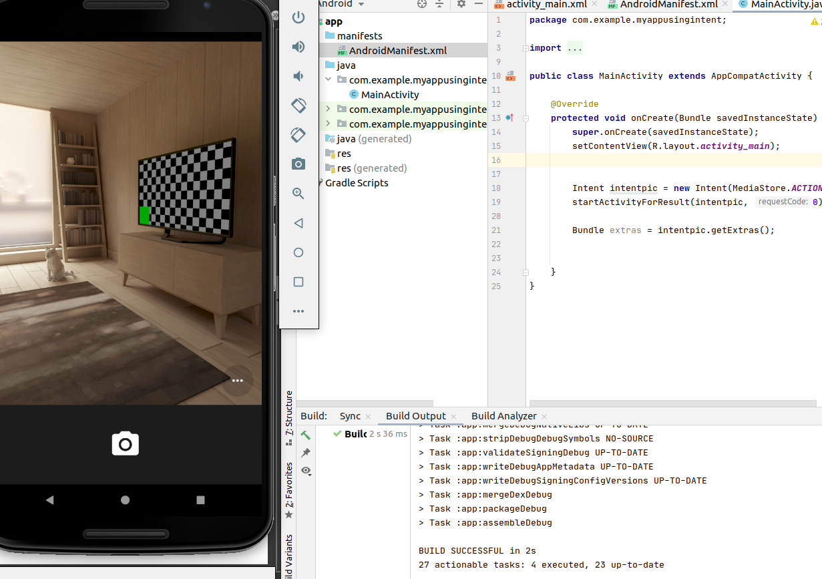.

* 通过浏览器打开网页

*//Web Browsing*  
Uri uri = Uri.*parse*(**"http://www.baidu.com"**);  
Intent intent = **new** Intent(Intent.***ACTION_VIEW*** ,uri);  
startActivity(intent);

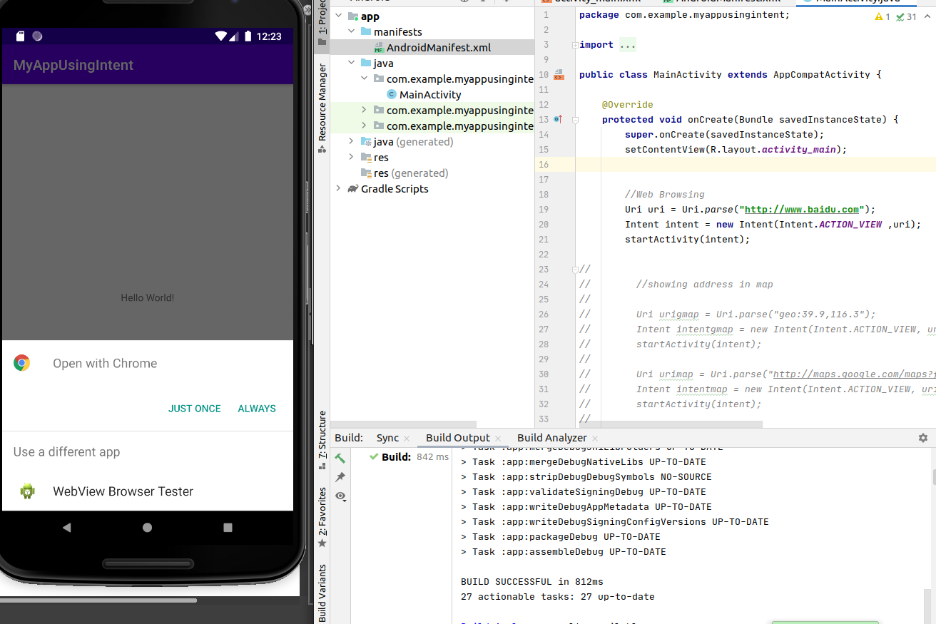.

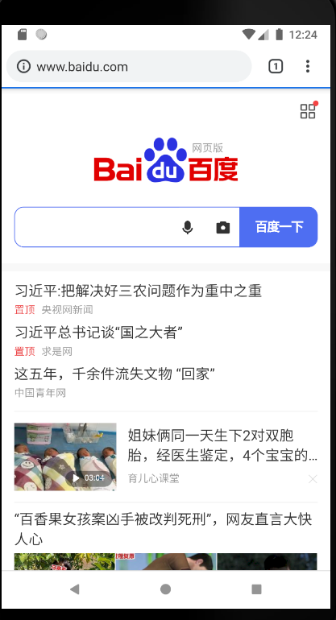.

.

* 显示地图与路径规划

*// showing address in map*  
  
Uri urigmap = Uri.*parse*(**"geo:39.9,116.3"**);  
 Intent intentgmap = **new** Intent(Intent.***ACTION_VIEW***, urigmap);  
 startActivity(intentgmap);  
  
 Uri urismap = Uri.*parse*(**"http://maps.google.com/maps?f=d&saddr=startLat%20startLng&daddr=endLat%20endLng&hl=en"**);  
 Intent intentsmap = **new** Intent(Intent.***ACTION_VIEW***, urismap);  
 startActivity(intentsmap);

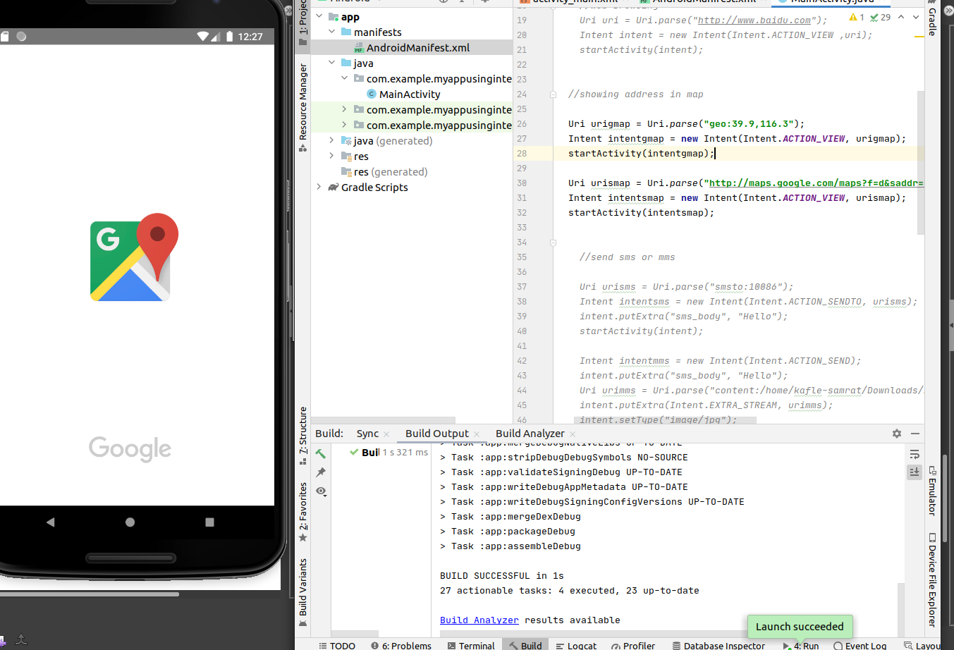.

* 发送短信或彩信

*//send sms or mms*  
  
Uri urisms = Uri.*parse*(**"smsto:10086"**);  
Intent intentsms = **new** Intent(Intent.***ACTION_SENDTO***, urisms);  
intentsms.putExtra(**"sms_body"**, **"Hello"**);  
startActivity(intentsms);  
  
Intent intentmms = **new** Intent(Intent.***ACTION_SEND***);  
intentmms.putExtra(**"sms_body"**, **"Hello"**);  
Uri urimms = Uri.*parse*(**"content:/home/kafle-samrat/Downloads/21523.jpg"**);  
intentmms.putExtra(Intent.***EXTRA_STREAM***, urimms);  
intentmms.setType(**"image/jpg"**);  
startActivity(intentmms);

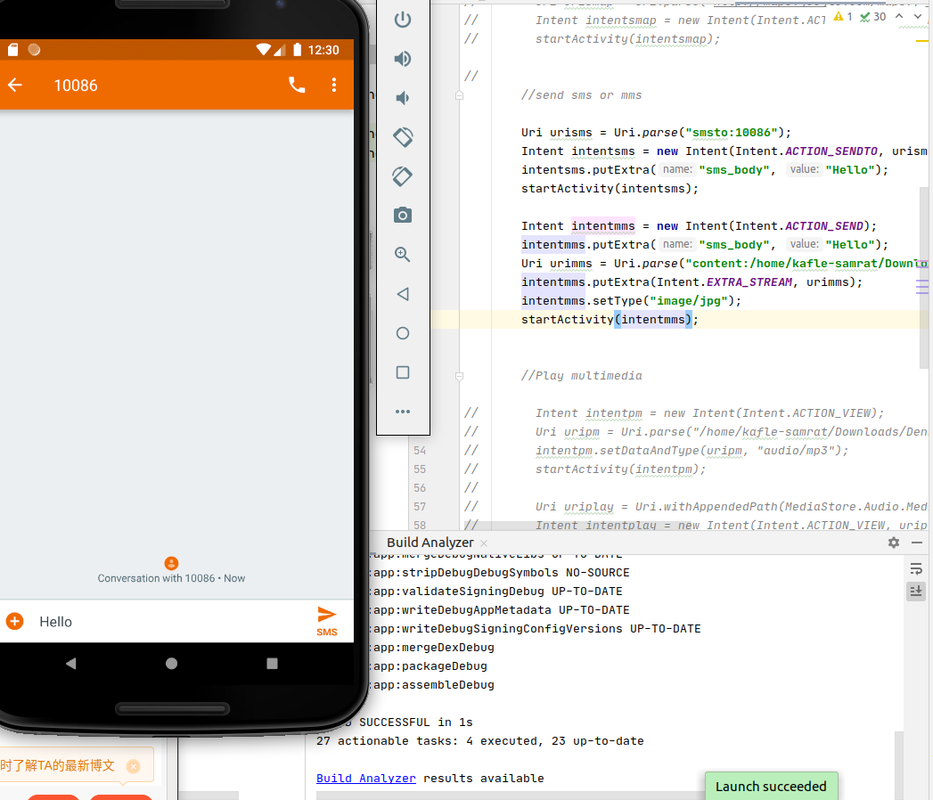.

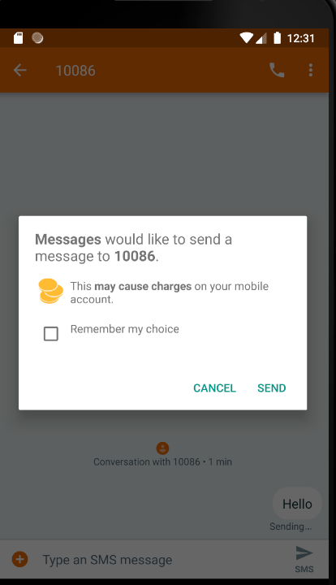.

.

* 发送电子邮件

*//sending email through gmail*  
  
Intent emailIntent = **new** Intent(Intent.***ACTION_SEND***);  
emailIntent.setType(**"plain/text"**);  
String address[] = **new** String[] { **"kafqq12@gmail.com"** };  
String subject = **"I'm Sam"**;  
String content = **"www.google.com"**;  
emailIntent.putExtra(Intent.***EXTRA_EMAIL***, address);  
emailIntent.putExtra(Intent.***EXTRA_SUBJECT***, subject);  
emailIntent.putExtra(Intent.***EXTRA_TEXT***, content);  
startActivity(emailIntent);

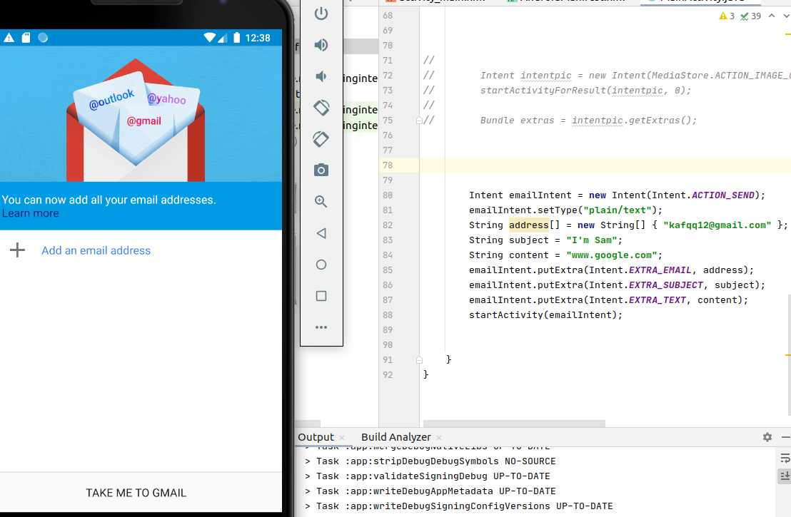

* 调用拨号程序

*//Showing call dialing screen*  
  
  
Uri uri = Uri.*parse*(**"tel:10086"**);  
Intent intent = **new** Intent(Intent.***ACTION_DIAL***, uri);  
startActivity(intent);

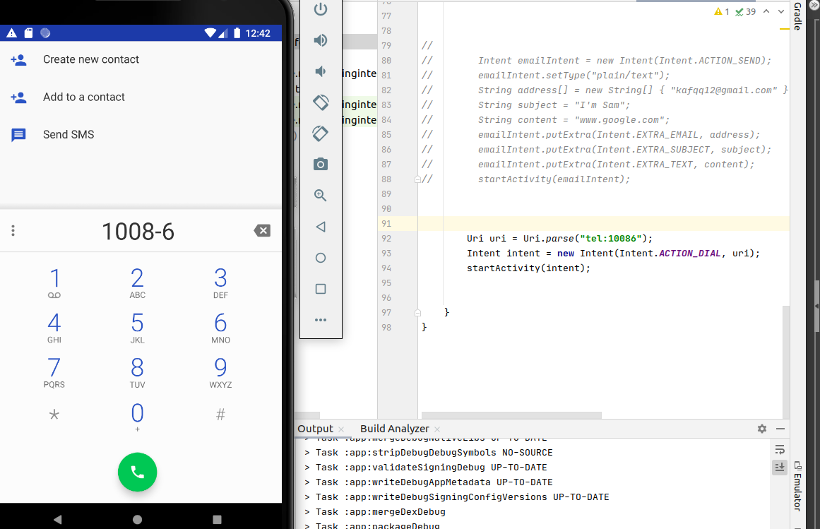.

AndroidManifest.xml

*<?***xml version="1.0" encoding="utf-8"***?>*  
<**manifest xmlns:android="http://schemas.android.com/apk/res/android"**  
 **package="com.example.myappusingintent"**>  
  
 <**application**  
 **android:allowBackup="true"**  
 **android:icon="@mipmap/ic_launcher"**  
 **android:label="@string/app_name"**  
 **android:roundIcon="@mipmap/ic_launcher_round"**  
 **android:supportsRtl="true"**  
 **android:theme="@style/Theme.MyAppUsingIntent"**>  
 <**activity android:name=".MainActivity"**>  
 <**intent-filter**>  
 <**action android:name="android.intent.action.MAIN"** />  
  
 <**category android:name="android.intent.category.LAUNCHER"** />  
 </**intent-filter**>  
 </**activity**>  
 </**application**>  
  
</**manifest**>